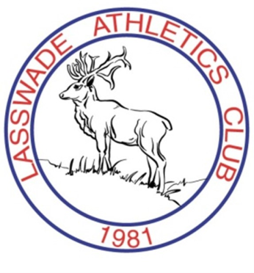
LASSWADE
Athletics Club
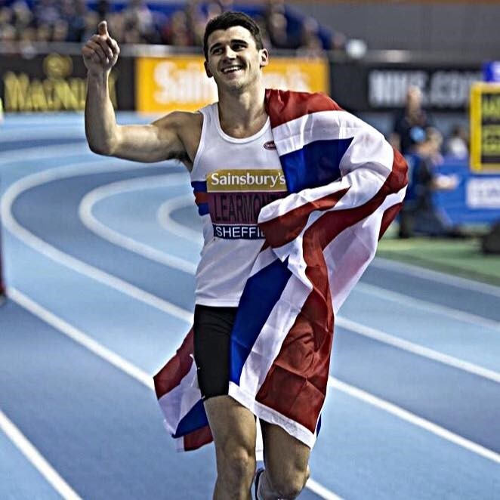

BRITISH INDOOR 800m CHAMPION

Ways to get in touch:

Website: www.lasswade
-
ac.org.uk

Twitter: @LasswadeAC

Facebook: Lasswade
Athletics Club

Telephone: 0131 561 6512￼

Lasswade Ac has a new British Champion in Guy Learmonth. Guy won Gold
on Sunday 15 February 2015 in Sheffield at the Sainsbury’s British Indoor Cham-
pionships. Leading from gun to tape in the 800m Guy was pushed all the way
but held on in a dramatic finish.

Afterwards a delighted Guy was quick to praise the people who have support-
ed him in reaching this milestone. None more so than his family, coaches and
friends .

And so it is on to the European Indoor Championships this month in Prague.

Congratulations from all at Lasswade Athletics Club . Great to see the club vest
winning on the national stage. Well Done!

March 2015

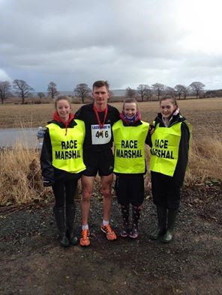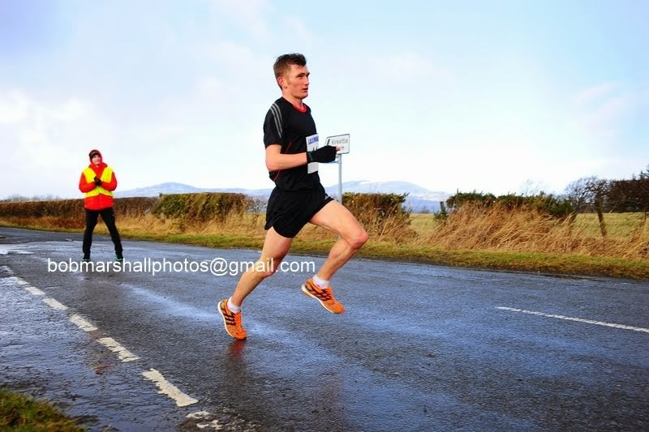LASSWADE 10 MILE ROAD RACE 1 MARCH 2015
Rosewell was the setting for the start of the Lasswade 10 Mile Road Race on 1 March 2015. The weather on the lead up to the day was windy and wet so why should it be any different for the race? 450 Signed up to take in the sights of Rosewell, Roslin, Auchendinny and Rosslynlee and climbs and descents of over 1900 feet which all goes to make this course a real challenge. Add the weather on the day – Snow, rain, hail and wind in abundance and this made the event not one for the faint hearted.
Supported by Run and Become, Whitehill House Golf Course and Midlothian
Council and assisted on the day by Police Scotland, Council Staff as well as Whitehill Welfare FC, Lasswade AC put on a fantastic event. The club was inundated with emails and messages of thanks including:-
I'd like to thank you for a fantastic turn out from your race officials and marshals. Despite the horrible weather, they all shouted encouragement with smiles on their faces. I appreciated their efforts and the great spread put on at the end. I think Whitehill Welfare also deserve a pat on the back for putting up with such a bunch of runners using their facilities - Moorfoot Runners
We would like to say a huge thank you to Lasswade AC for organising a great race today, we really appreciate you going to so much effort! The course was well marshalled and marked very clearly with no doubt as to what the route was. Great support from the marshals and thanks to the team of kids at the end for dishing out the medals and water - they must have been as cold as the runners were. What can we say about the fantastic spread of food afterwards, it was incredible?! Please also pass on our thanks the officials and time-keepers.
Penicuik Harriers will be back next year! - Penicuik Harriers
To the race itself and with a quality field Derek Hawkins from Kilbarchan AAC won through in a fantastic time of 51 minutes 8 second some distance ahead of the chasing pack (Ross Houston Central AC, David Millar Irvine RC)
Congratulations to everyone involved. For more pictures please visit Bob Marshall Sports Photography
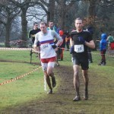
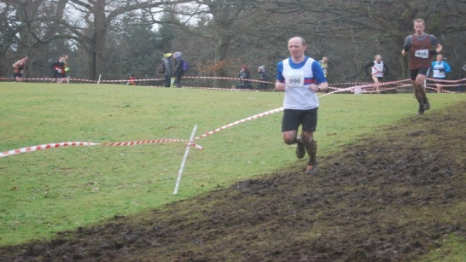
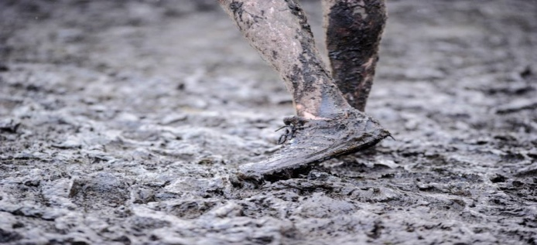
https://picasaweb.google.com/113562417702657933373/ LASSWADE10MILERACE2015?

National Cross Country Championships , Callendar Park, Falkirk
February saw The National Cross Country Championships at Callendar Park in Falkirk. Numbers supporting this event was the biggest in 20 years and despite the cold and wet weather and mudbath appearance most appeared to cope with the conditions overhead and underfoot admirably.
All runners are to be commended as conditions worsened with stray Gazebos strewn across the course like tumbleweed as the day went on.
Performance of the day goes to the u15 Girls team who finished 3rd overall. So a podium place for Sarah Tait , Lauren Dickson, Eilidh Brown and Lauren Wilkie
Other performances on the day
Under 13 boys - Graham Lambert (40th), Kurt Robertson (86th)
Under 13 Girls – Hannah Little (58th),Ellie Baxter (109th),Kaerdy Macdonald(113rd), Abby McGlone (141st)
Under 15 Boys – Magnus Tait (18th), Jamie Darling (39th),Thomas Snodgrass (88th), Euan Mackay (116th),Daniel Kelly (118th) Ben Keay (121st),Euan McAllister (128th)
Under 17 Boys – Kyle Mackenzie (61st), Sam Talebi (74th) Cameron Steven (DNF)
Amy Frankland representing Edinburgh University Hare & Hounds (but really a Lasswade athlete) finished 12th in the under 20 women’s race.
Senior Men - Martin Gore (79th), Owen Miller (145th), Paul Benham (199th ) Doug McDonald (427th)

SPRING / SUMMER FIXTURES
Day | Date | EVENT | Venue
Fri | 22nd May | East District Champs | Grangemouth
Sat | 23rd May | East District Champs | Grangemouth
Sun | 7th June | Scottish Masters Champs | Grangemouth
Sat | 20th June | Scottish Superteams | Grangemouth
Sat | 11th July | Scottish Combined Events Champs. | Pitreavie
Sun | 12th July | Scottish Combined Events Champs. | Pitreavie
Sat | 1st Aug | Celtic Games | Grangemouth
Sat | 15th Aug | Scottish Senior Champs | Aberdeen
Sun | 16th Aug | Scottish Senior Champs | Aberdeen
Sat | 22nd Aug | Scottish Age Group Champs | Grangemouth
Sun | 23rd Aug | Scottish Age Group Champs | Grangemouth
Sunday | 6th Sept | Relay Fest | Grangemouth
SCOTTISH | SCHOOLS
Fri | 5th June | Scottish Schools Secondary Relay Champs | Hutchesons Grammar
Sat | 6th June | Scottish Schools Pentathlon &Relay Champs | Grangemouth
Fri | 12th June | Scottish Schools Champs | Grangemouth
Sat | 13th June | Scottish Schools Champs | Grangemouth
Thurs | 18th June | Scottish Schools Inter Area & Disability Champs | Grangemouth
Sat | 18th July | Schools International | Grangemouth
SCOTTISH | UNIVERSITIES
Sat | 25th April | Outdoor Championships | Grangemouth
LEAGUES | MEETINGS
Sat | 6th June | UKWAL | Meadowbank
Sun | 9th Aug | UKWAL | Scotstoun
Sun | 26th April | SWAL | Aberdeen
Sun | 14th June | SWAL | Meadowbank
Sun | 30th Aug | SWAL | Grangemouth
Sun | 5th April | Lothian Trials | Meadowbank
Sun | 10th May | SAL | Grangemouth
Sun | 14th June | SAL | Inverness
Sun | 5th July | SAL | Kilmarnock
Sun | 30th Aug | SAL | Meadowbank
Sun | 3rd May | YDL U13/U15 Div 2 | Kilmarnock
Sat | 30th May | YDL U13/U15 Div 2 | Grangemouth
Sun | 21st June | YDL U13,U15 Div 2 | Kilmarnock
Sun | 9th Aug | YDL Final | Grangemouth
Sun | 26th July | YDL U17/U20 | Scotstoun
Sat | 18th April | Forth Valley Leagu | Grangemouth
Sat | 16th May | Forth Valley Leagu | Meadowbank
Sat | 27th June | Forth Valley Leagu | Grangemouth
Sat | 5th Sept | Forth Valley Leagu | Meadowbank
Sun | 17th May | CSSL Div 2/3 | East Kilbride
Sun | 28th June | CSSL Div 2/3 | Grangemouth
Sun | 2nd August | CSSL Div 2/3 | Kilmarnock
March15 issue 4

SPRING SUMMER FIXTURES (Contd)
Sat | 11th April | Pitreavie Club Champs | Pitreavie
Sun | 12th April | Pitreavie Club Champs | Pitreavie
Sun | 6th Sept | Pitreavie Young Athletes Trophy | Pitreavie
Wed | 22nd April | Livingston OGM | Craigswood
Wed | 27th May | Livingston OGM | Craigswood
Wed | 15th July | Livingston OGM | Craigswood
Wed | 19th Aug | Livingston OGM | Craigswood
Sat | 8th Aug | Livingston Combined Events Meeting | Craigswood
Sat | 9th May | East Lothian OGM | Meadowmill
Tues | 23rd June | East Lothian OGM | Meadowmill
Tues | 11th Aug | East Lothian OGM | Meadowmill
Sat | 29th Aug | East Lothian OGM | Meadowmill
Wed | 29th April | Dunren OGM | Linwood
Wed | 6th May | Falkirk OGM | Grangemouth
Wed | 3rd June | Falkirk OGM | Grangemouth
Wed | 1st July | Falkirk OGM | Grangemouth
Wed | 5th Aug | Falkirk OGM | Grangemouth
Wed | 2nd Sept | Falkirk OGM | Grangemouth
Sat | 28th March | Wishaw OGM | WishawSat
AREA SCHOOLS
Wed | 3rd June | Edinburgh Sec Schools Champs | Meadowbank
DISABILITY | MEETINGS
Sunday | 29th March | Central Time Trials inc. SDS Squad | Grangemouth
Wed | 3rd June | SDS Junior Track & Field Champs | Grangemouth
Wed | 10th June | Fife Disability Track & Field Champs | Pitreavie
Wed | 9th Sept | SDS Senior Track & Field Champs | Perth
—
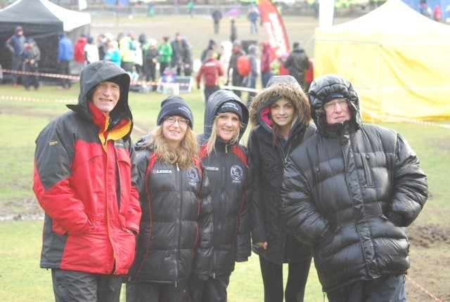
CAN YOU HELP ?

Lasswade AC are looking for helpers to assist on
Monday and Thursday

Anyone willing to help please contact Brian Hood,
Club Development Officer on -
Brian.hood@midlothian.gov.uk , 0131 561 6512 or
coaches down at the Dalkeith Campus

COME ALONG

HELP US OUT !!

Congratulations to David Hand who wins this season’s

Michelin man look alike. He fought off some stiff compe-
tition at the Falkirk XC where several ran him close

