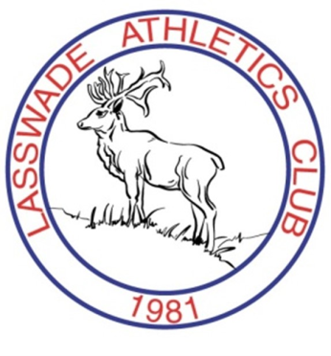
LASSWADE
Athletics Club

Club Championships – Sunday 20 September 2015, Meadowbank
The annual Club Championship takes place at Meadowbank next month and all those wanting to take part should by now have a form.
This great event, run by the club marks the end of the track season and what better way to sign off than with a PB or an event you have never tried before.
There is a run, jump and throw event for younger runners and a full track and field card for u11-Masters .
Forms are available on our webpage and facebook. Form to be returned to David McConnell by 1 September 2015 if possible. SEE YOU THERE !!!

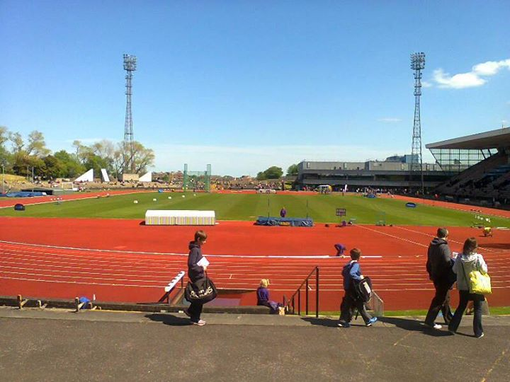

Lasswade AC Open Cross Country – 01/11/2015
The 34th Lasswade Athletics Club open cross country event takes place on Sunday 01 November 2015 at Gore Glen Playing Fields, Engine Road, Gorebridge, Midlothian.
This is one of the few open events that remain on the cross country calendar. There are races for all age groups from under 11 to senior/vets, so mark the date in your diary and we’ll look forward to seeing you on the day!
Adult entries are being taken NOW via Entry Central- http://www.entrycentral.com/festival/706
Children and Juniors will sign in on the day at Gorebridge leisure centre. Showering facilities will be available at Gore Glen playing fields

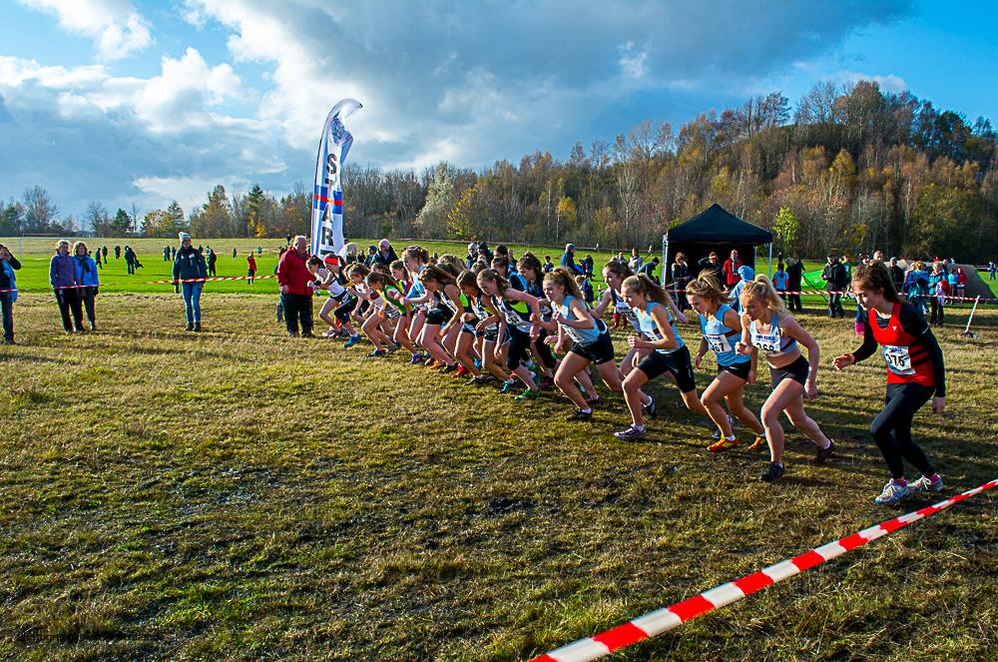

DATE FOR YOUR DIARY
November 2015 Disco – Club Disco and Prize giving
November 6 Woodburn Miners Club
WINTER FIXTURE LIST - PROVISIONAL
2015
Sunday | 11-Oct | East CC Relays | Peebles
Saturday | 24-Oct | Nat CC Relays | Cumbernauld
Sunday | 01-Nov | Lasswade AC Cross Country | Gorebridge
Saturday | 07-Nov | Nat Short Course Champs | Bellahouston Park, Glasgow
Saturday | 12-Dec | East CC Champs | Livingston
2016
Saturday | 09-Jan | Inter District Championships | Holyrood Park, Edinburgh
Saturday | 16-Jan | National Open | Emirates, Glasgow
Saturday | 30-Jan | Scottish Seniors | Emirates, Glasgow
Saturday | 30-Jan | Nat Masters CC Champs | Forres
Sunday | 07-Feb | SuperTEAMS (U12s) | Emirates, Glasgow
Saturday | 13-Feb | Age Groups | Emirates, Glasgow
Sunday | 14-Feb | Age Groups | Emirates, Glasgow
Saturday | 20-Feb | Sainsbury’s Grand Prix | Emirates, Glasgow
Saturday | 27-Feb | Nat CC Champs | Falkirk
Saturday | 05-Mar | Combined Events; Masters track and field | Emirates, Glasgow
Sunday | 06-Mar | Combined Events; Senior Relays | Emirates, Glasgow
Sunday | 06-Mar | Lasswade AC 10 Mile Road Race | Rosewell
Saturday | 02-Apr | Nat Young Athletes Road Champs | Greenock
Sunday | 03-Apr | Nat 6/4 Stage Road Relays | Livingston
Sunday | 06-Mar | Combined Events; Senior Relays | Emirates, Glasgow

