East District League – Alloa 21/11/2015
The second east district cross country race took place at Alloa last Saturday. Although a dry and beautiful day the course was extremely muddy from rain over the course of the previous week. After a reasonable start at Stirling, the number of Lasswade athletes competing was good with 34 athletes, only three runners short of having complete teams in all age groups.
The days racing began with the under 11 girls, with two Lasswade athletes running. Olivia Meikle had a great run to finish in 4th place with team mate Amy McLaughlin finishing strongly in 40th place.
Next off were the under 11 boys with Dexter Howard leading them home with a very good run in 7th place, team mate Alistair Scott was next in 38th followed by Alex Miller 41st, Alasdair Brown 43rd and Jonathan Adams completing the team in 60th.
In the under 13 girls Hannah Little maintained her good form finishing 6th, Lauren Meikle (pictured below) still smiling after all that mud finished 37th with Abby McGlone in 60th place.
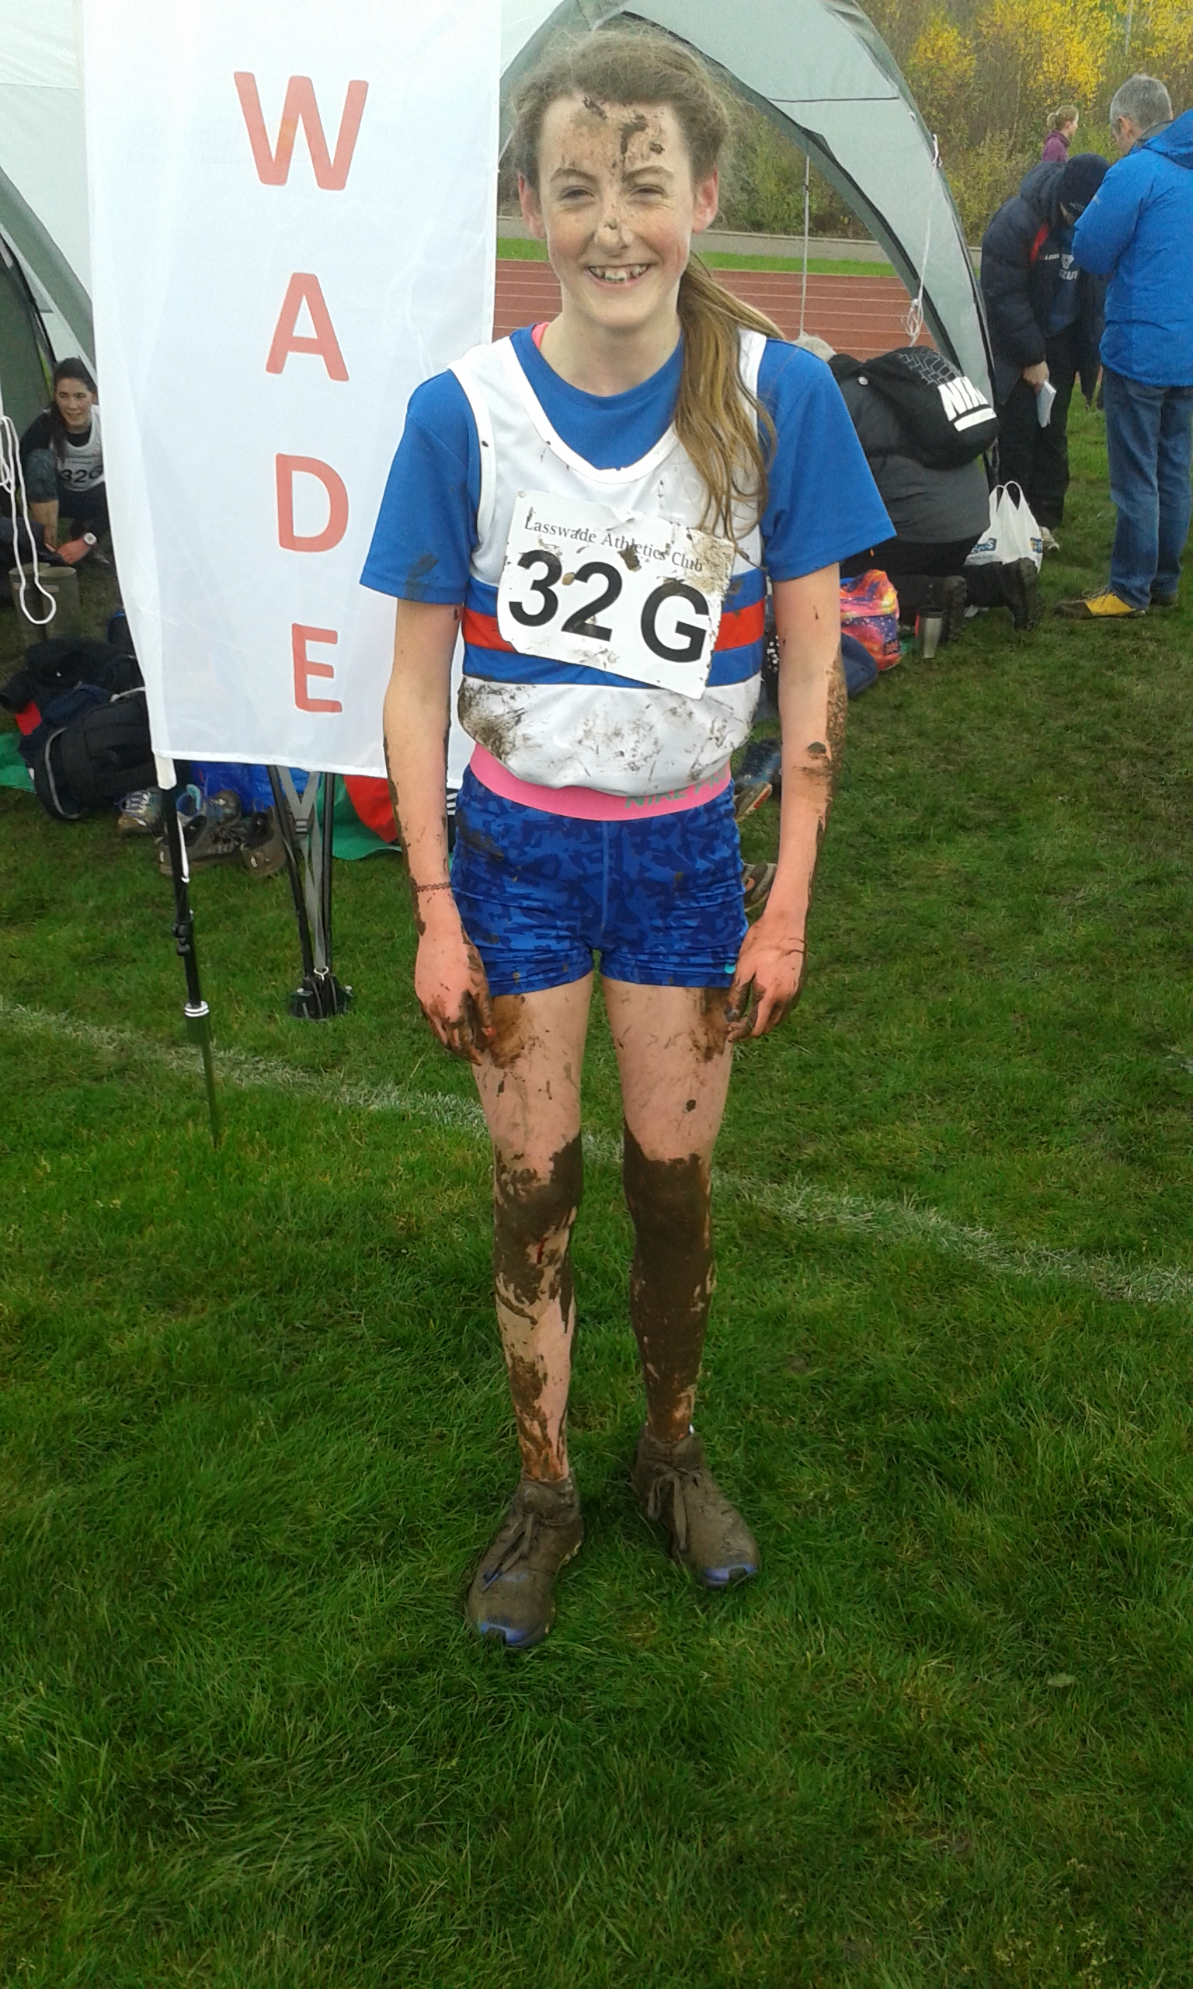
Harry Henriksen and his Mum made a great effort to get to the race straight from a school rugby match. It was a close call but they made it and Harry had another good run finishing in 5th place with team mate Cameron Dickson running well to finish 45th.
Lasswade had good numbers in the under 15 boys race with Magnus Tait leading them home with a good run in 5th place followed by Euan Hood who also had a good run finishing 12th, next home was Daniel Kelly 45th, Euan Simon 46th, Rory Ferguson 49th and Euan McAlister in 52nd.
The under 15/17 girls produced our only winner of the day with Lauren Dickson breaking clear on the second of her two laps, after putting an effort in as she went up the hill for the second time. Sarah Tait not feeling 100% still finished 9th overall (3rd U15) with Ailsa Innes 18th and Eilidh Brown 27th (15th U15). Lauren Wilkie had to pull out of the race unwell.
In the under 17 Men’s race Matthew Smith had a strong run to finish 12th with Jamie Darling running well in 20th place.
Niamh Shaw ran well in the Ladies race to finish in 51st place closely followed by Cathy Dickson in 53rd place.
As usual the final race of the day was the men and we had seven runners. Martin Gore ran well to finish just outside the top 40 in 41st place, the next three runners were packing well for much of the race with Doug McDonald 139th, Ben Mitchell 141st and Scott Dickson 167th. Next home was Stephen Brown in 222nd, Derek Wilkie 253rd and Phil Parr-Burman completing the team in 258th.
It’s great to see many athletes coming out and running for the club. It really does make it all worthwhile. There are a lot of athletes finishing at the top end of the field and assuming we have similar performances at the East District Champs in Livingston there should be quite a few athletes selected for the Inter District at Holyrood in January. This is great for the individual athletes but is also fantastic for the club.
Well done to everyone and thanks for making the effort!
Looking forward to Livingston.
Kirk

