NATIONAL SHORT COURSE CROSS COUNTRY CHAMPIONSHIPS
BELLAHOUSTON PARK, GLASGOW
07 NOVEMBER 2015

The above event took place last weekend and Lasswade Athletics Club had a number of athletes competing in the under 15 girls and boys and under 17 men and women age groups.

The conditions were terrible it looked like it had been raining for days as Bellahouston park was waterlogged, the rain continued to pour down and showed no sign of easing as the first race of the day lined up, the under 15 girls.

Lasswade AC has two athletes competing in this race Sarah Tait and Eilidh Brown. Sarah Tait was with the leaders from the gun and soon settled into 2nd place. Sarah had a fine race finishing in 2nd place but was closing on the leader and winner Eloise Walker of Edinburgh AC all the way to the finish, in the end losing by just a couple of seconds. Team mate Eilidh Brown had a good run finishing in 36th place out of 66 finishers.

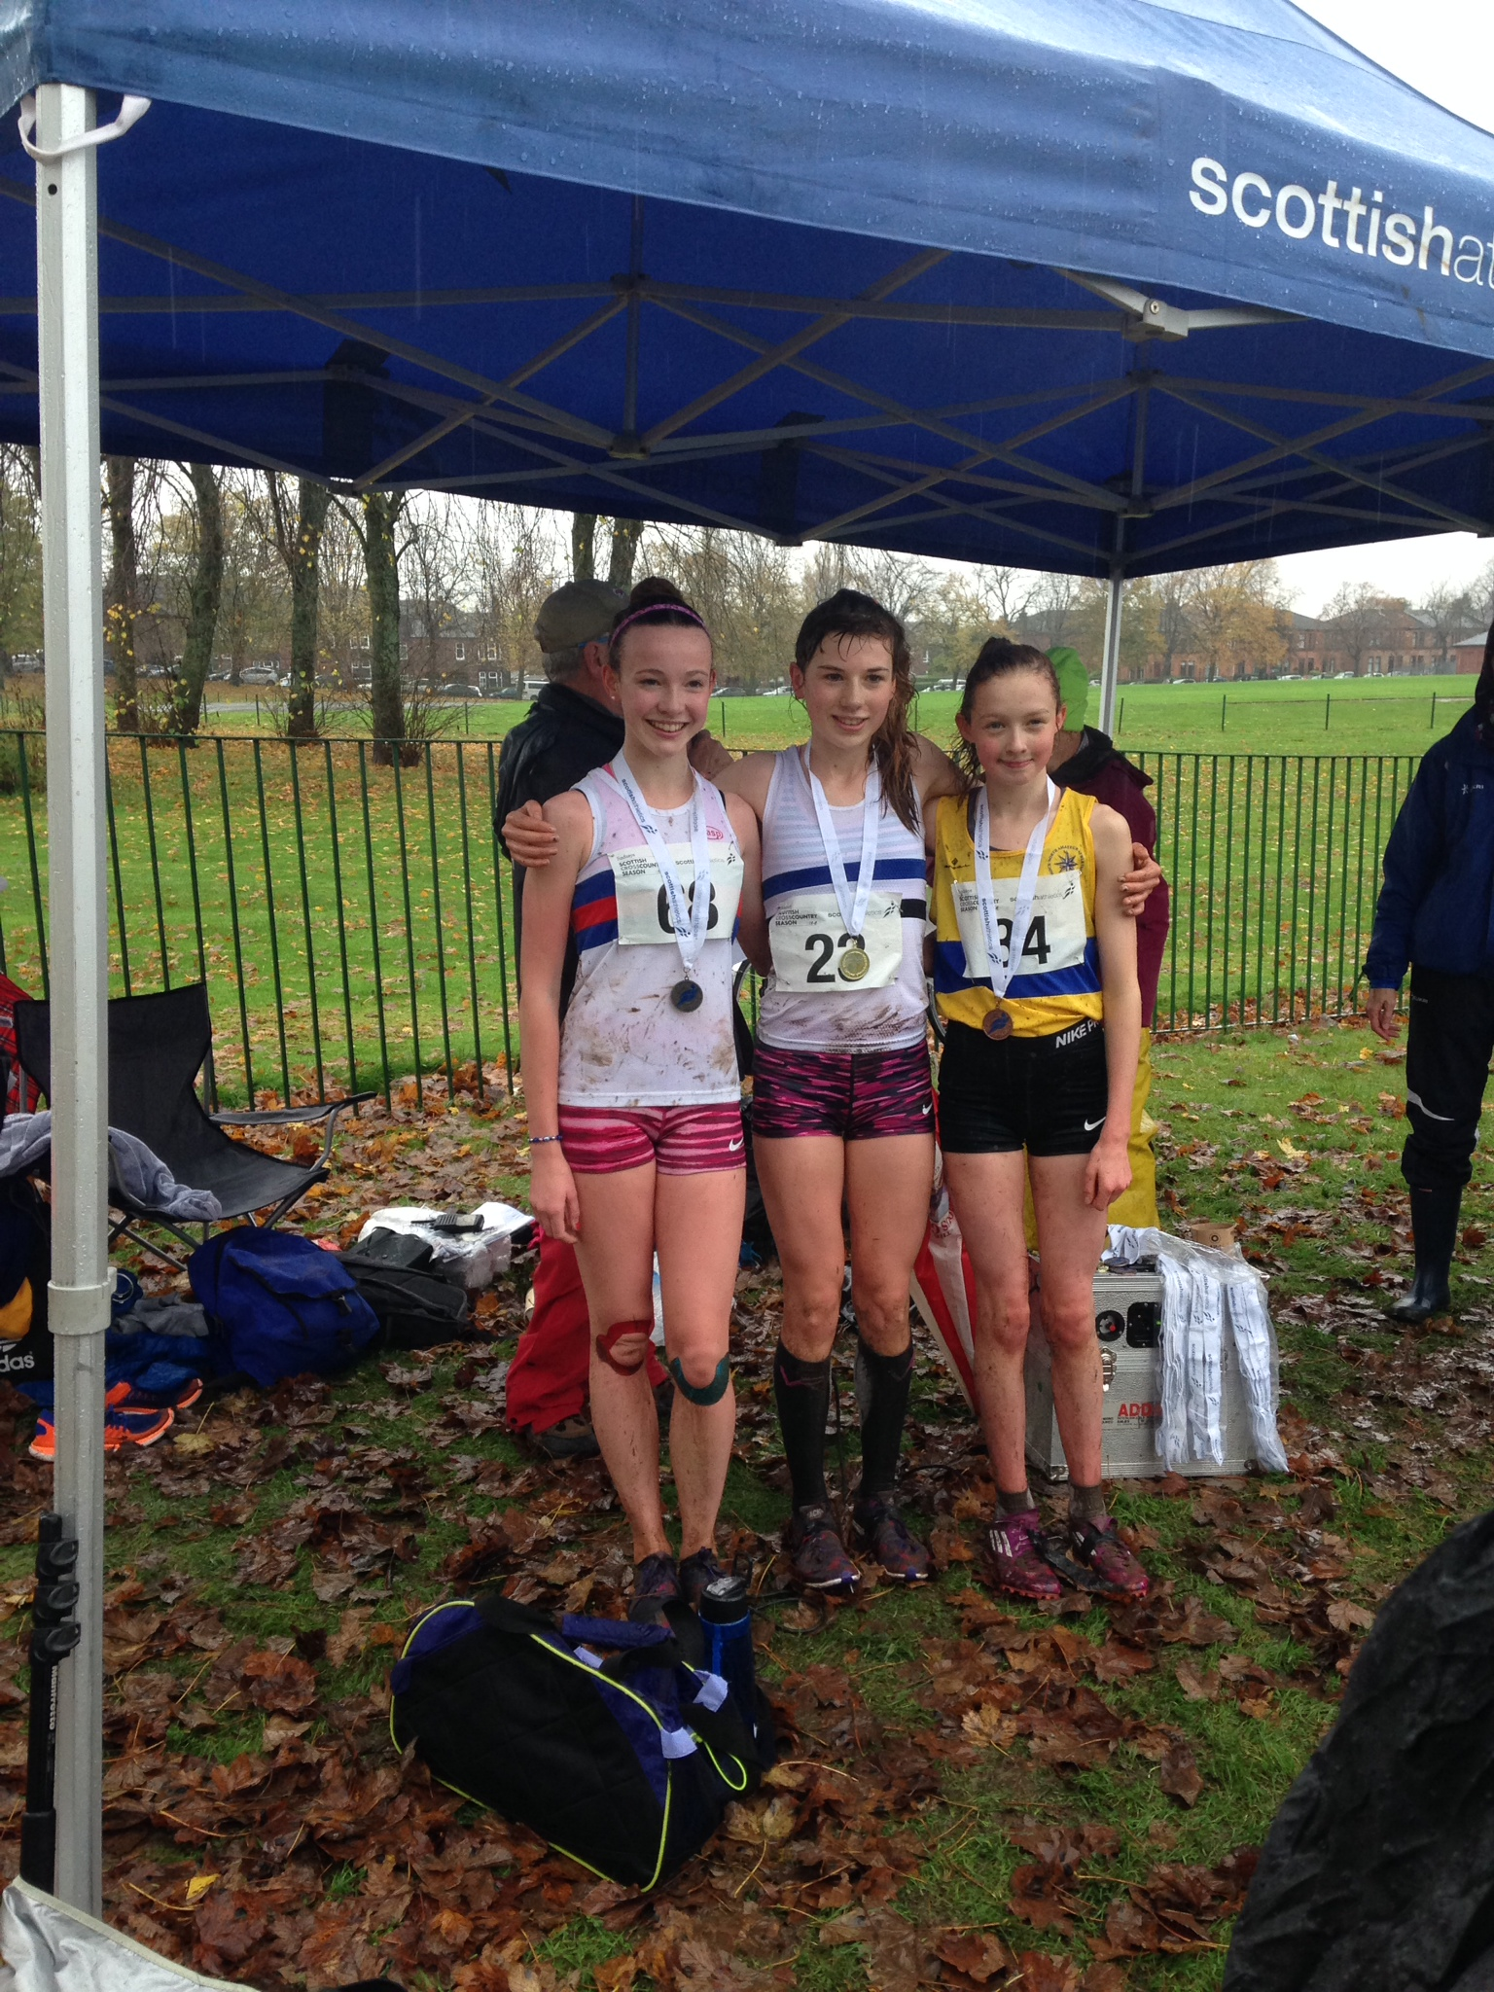

Sarah Tait (far left with silver medal!)

Next it was the under 15 boys and there were five Lasswade AC athletes competing, Magnus Tait, Euan Hood, Euan Simon, Euan McAllister and Rory Ferguson. Magnus Tait and Euan Hood led the Lasswade athletes running in a group of athletes just off the leaders with their team mates a little further back. Magnus had a strong run to finish in 12th with Euan a couple of seconds back in 15th. Our other finishers were Euan Simon 71st, Euan McAlister 72nd and Rory Ferguson 74th.

The under 17 women was the next race with Lauren Dickson, Ailsa Innes and Lauren Wilkie running for Lasswade AC. A group of four runners including Lauren Dickson broke clear on the first of the two laps with Lauren and Naomi Lang of Aberdeen AAC sitting in 3rd and 4th place behind the leaders Erin Wallace from Giffnock and Kate Gallagher from Central AC. Lauren moved into 3rd place and began to open a gap on the Aberdeen athlete which she maintained through to the finish. Team mate Ailsa Innes had a good run finishing in 19th place with Lauren Wilkie completing the team in 28th. Unfortunately, the girls just missed out on a bronze team medal finishing 4th team.

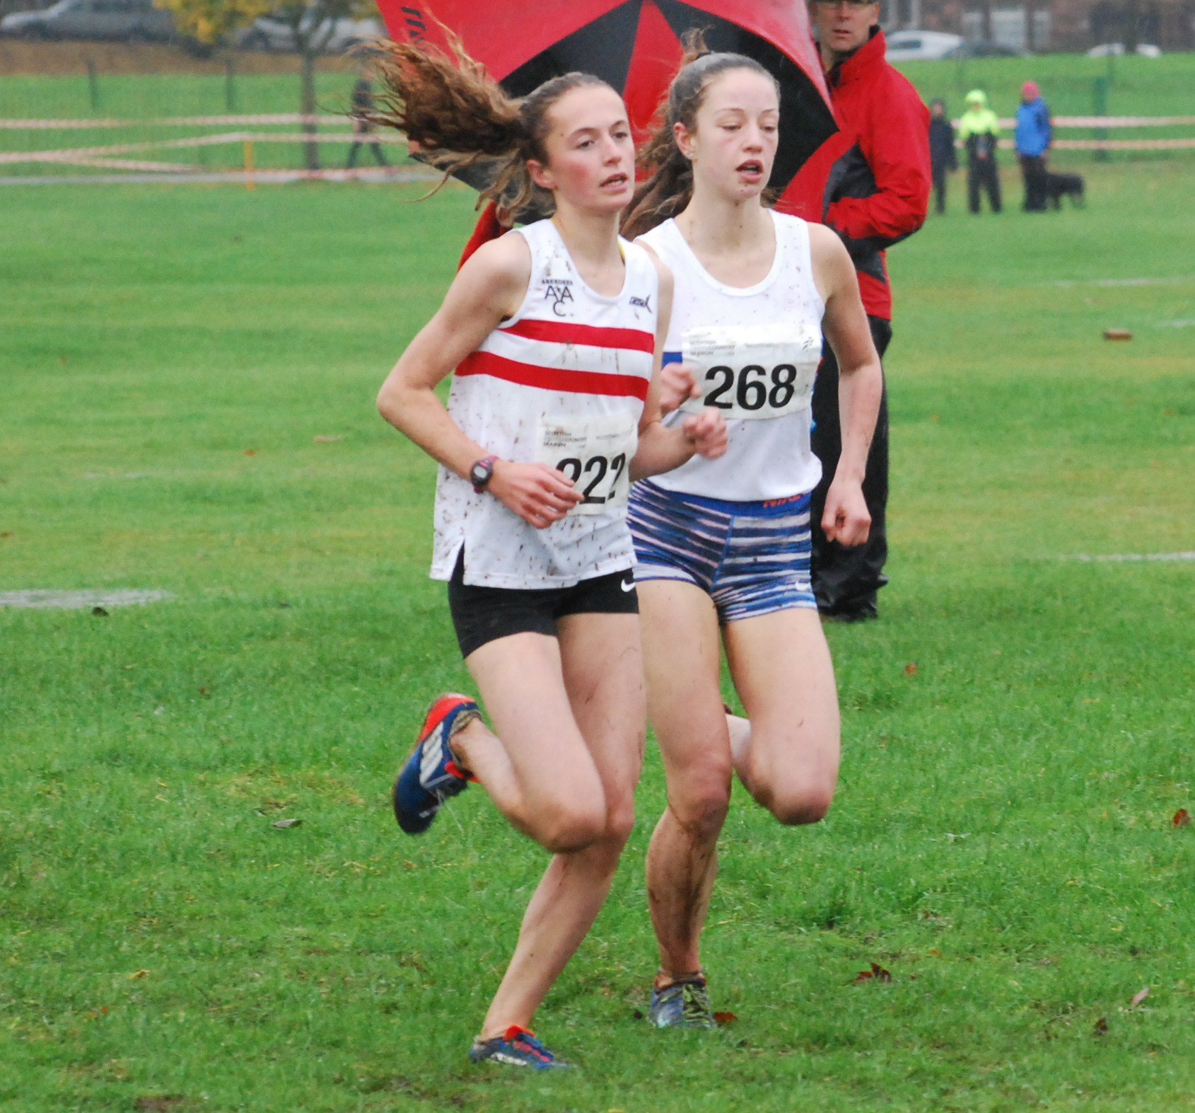

Lauren Dickson and Naomi Lang

The under 17 men was the final race for us and we had three athletes competing, Cameron Steven, Matthew Smith and Jamie Darling. Cameron Steven led the Lasswade AC athletes sitting in a large group of athletes behind the leaders. Cameron ran very well to finish in 10th place. Matthew Smith was our next finisher with a good run in 24th place and Jamie Darling completed the team finishing 53rd.

A great day (apart from the weather) and nice to leave with a couple of medals!

