NATIONAL CROSS COUNTRY CHAMPS – FALKIRK 2016

The first race of the day was the under 13 boys and Lasswade AC had two athletes competing, Harry Henriksen and Cameron Dickson. Harry had ran well at the inter district championships last month so hopes were high that he would finish near the front of the field. He started well settling down in around 10th place and working his way through to finish a very impressive 6th of the 155 finishers. Cameron ran a solid race to finish in 138th place.
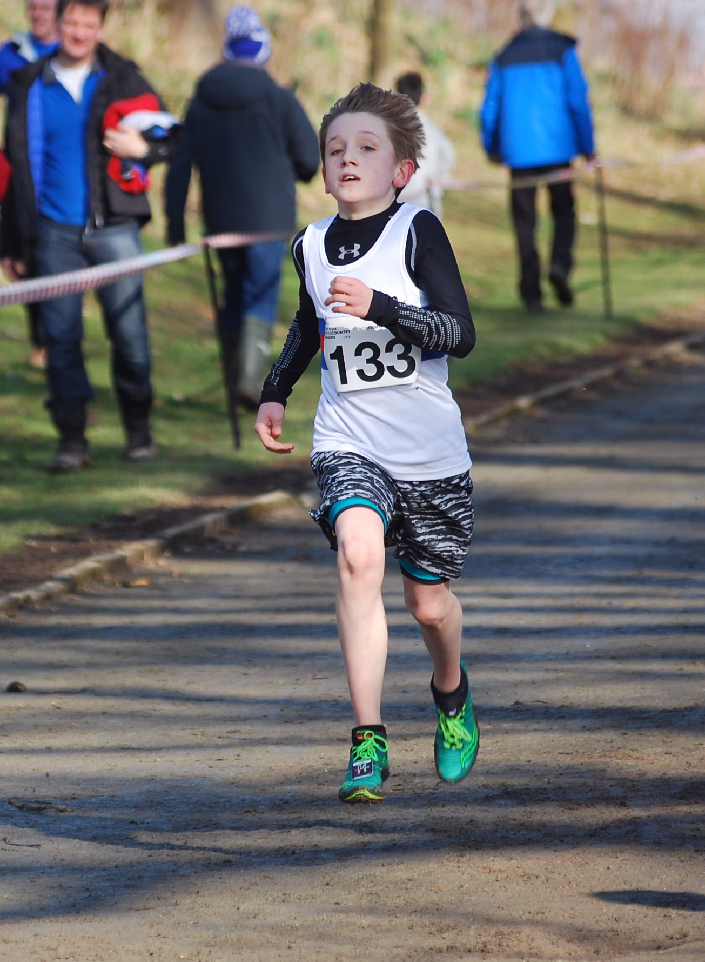
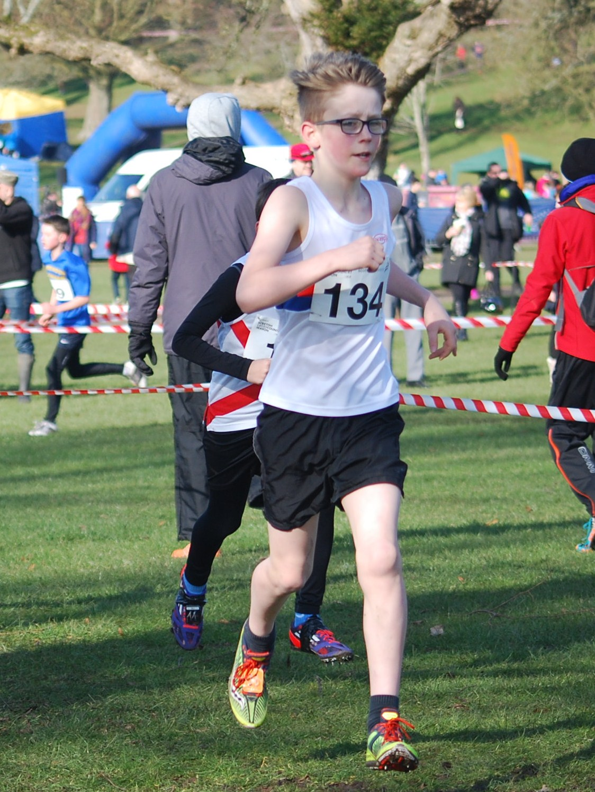

Harry (133) and Cameron (134) in action!

Next off it was the under 13 girls with Hannah Little and Abby McGlone our only two runners as Ellie Baxter had to withdraw with a chest infection.

Hannah too had been selected for the inter districts last month where she was disappointed with her run. Today her run was much better and more consistent with her form this season finishing inside the top 20 in 17th place out of the 149 finishers. Abby has been racing more this season than previously and we are seeing improvements both in training and racing. Abby had another good run in 73rd place.

As one race was finishing another was underway and the under 15 boys were next to the start line. Our three runners were Magnus Tait, Euan Hood and Daniel Kelly. All boys had been running well over the winter and the race went to form with Magnus having a strong run but suffering with a bit of a cold he still finished in 17th, Euan was next home with a good run in 31st with Daniel improving all the time and finishing 106th. There were 136 finishers.

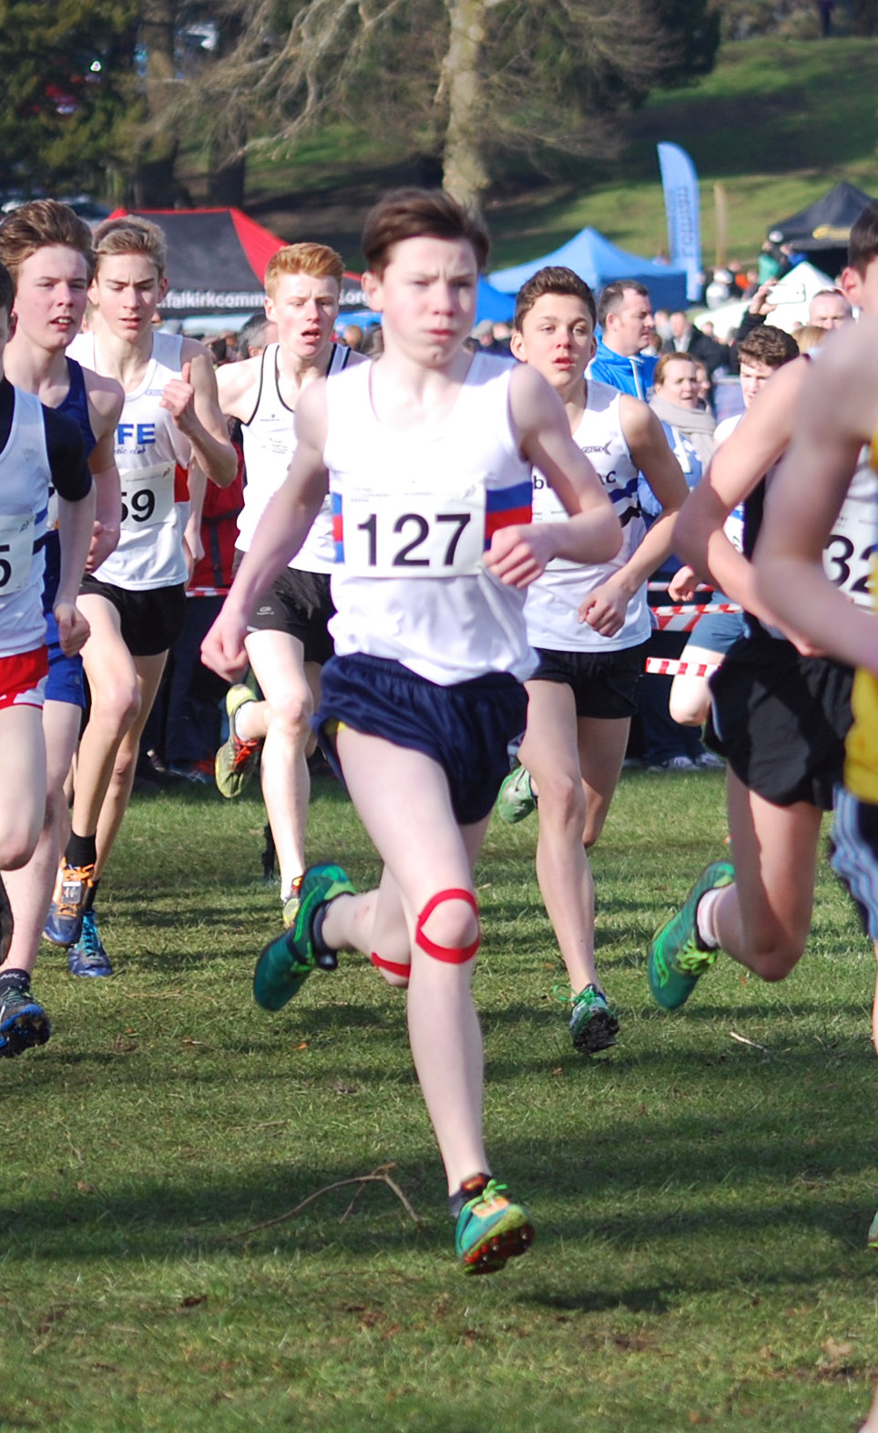

Magnus heads out on to the course!

The under 15 girls were the only young athletes age group where we managed to field a complete team of four runners, which is very disappointing. Our runners were Sarah Tait, Eilidh Brown, Caroline McKinlay and Keanna MacInnes. Sarah had finished in the top five last year so hopes were high, although having had some problems with her calves over the last few weeks she hadn’t had the best preparation. Sarah ran very well to finish 5th of the 101 finishers. Team mate Caroline McKinlay was next home with a good run in 49th place, followed by Eilidh Brown in 73rd place and Keanna MacInnes in 83rd place.

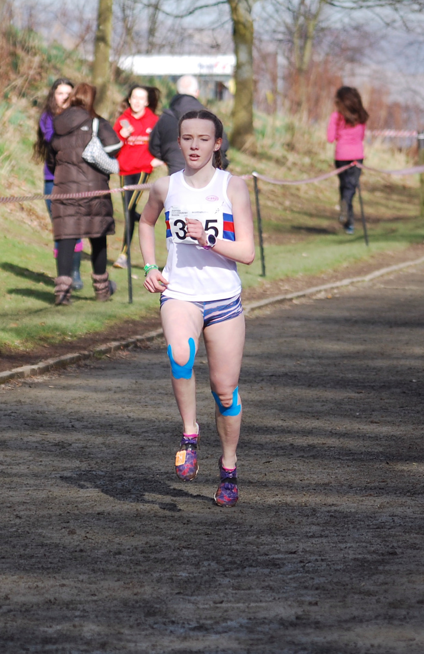
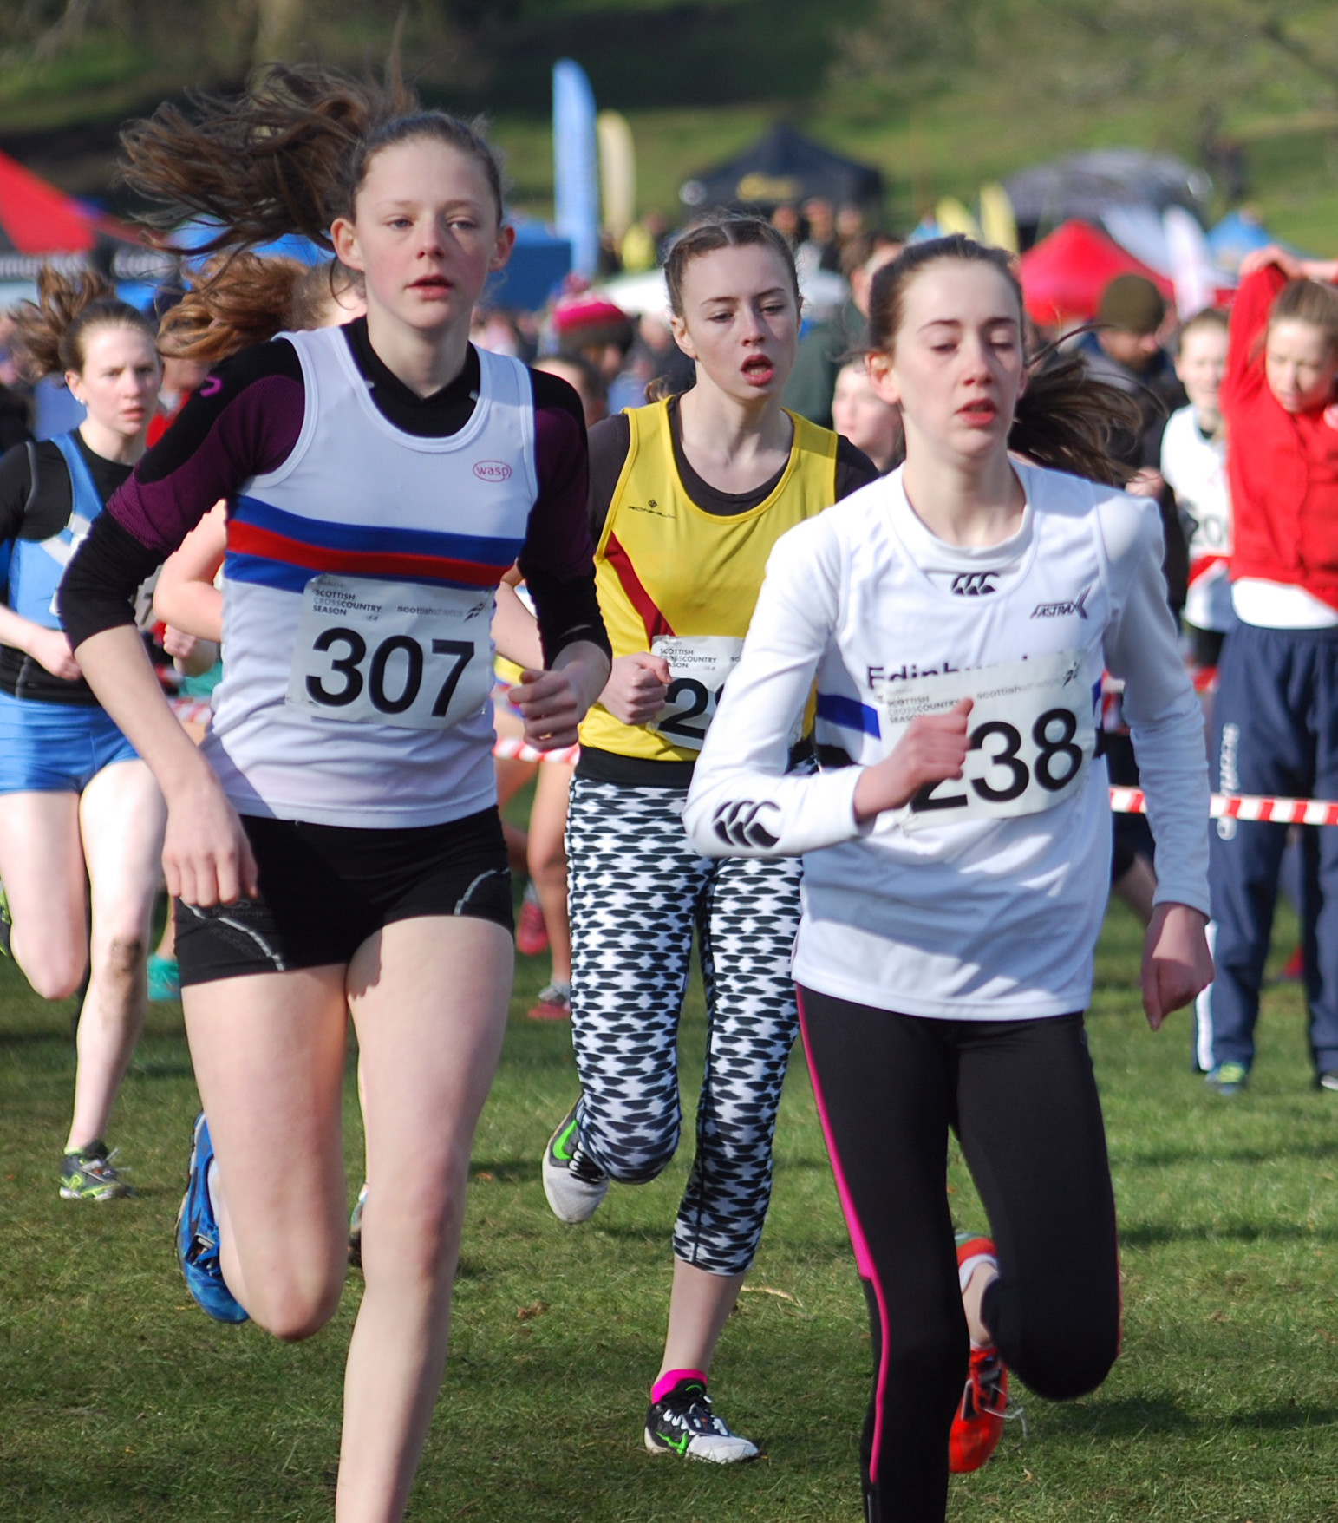

Sarah coming down towards the finish! Caroline heading out on to the big lap.

We had three under 17 female runners, Lauren Dickson, Ailsa Innes and Lauren Wilkie and they were next to the start. This was another race where we believed there was a good chance of an individual medal with Lauren Dickson who has been running well all season. It was also probably the race that had the biggest upset of the day, many people thinking it would be two horse race between Erin Wallace of Giffnock, who was the strong favourite and Kate Gallagher of Central. Neither girl was amongst the medals, however our own Lauren Dickson had a fantastic run to finish 2nd and pick up the silver medal! Lauren had set out her stall early in the race and was with the leading group looking determined and focused. Lauren dug in over the final 600m of the undulating course to open a bit of a gap and claim 2nd place. Ailsa Innes had a strong run to finish in 23rd place followed by team mate Lauren Wilkie in 46th place out of 61 finishers.
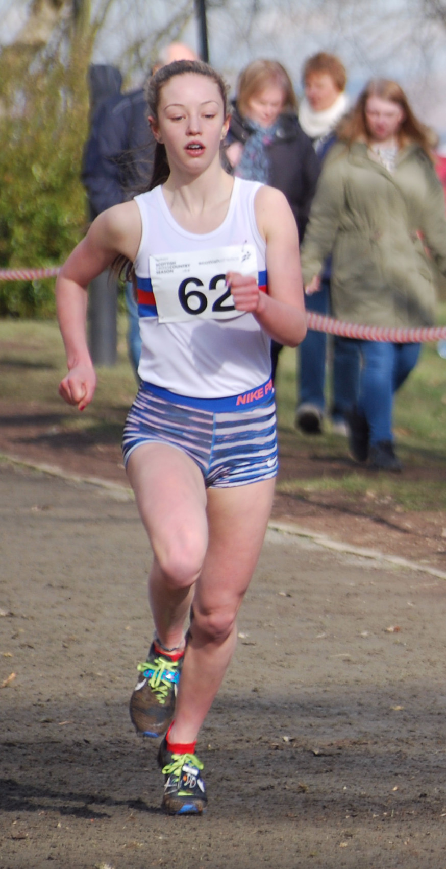
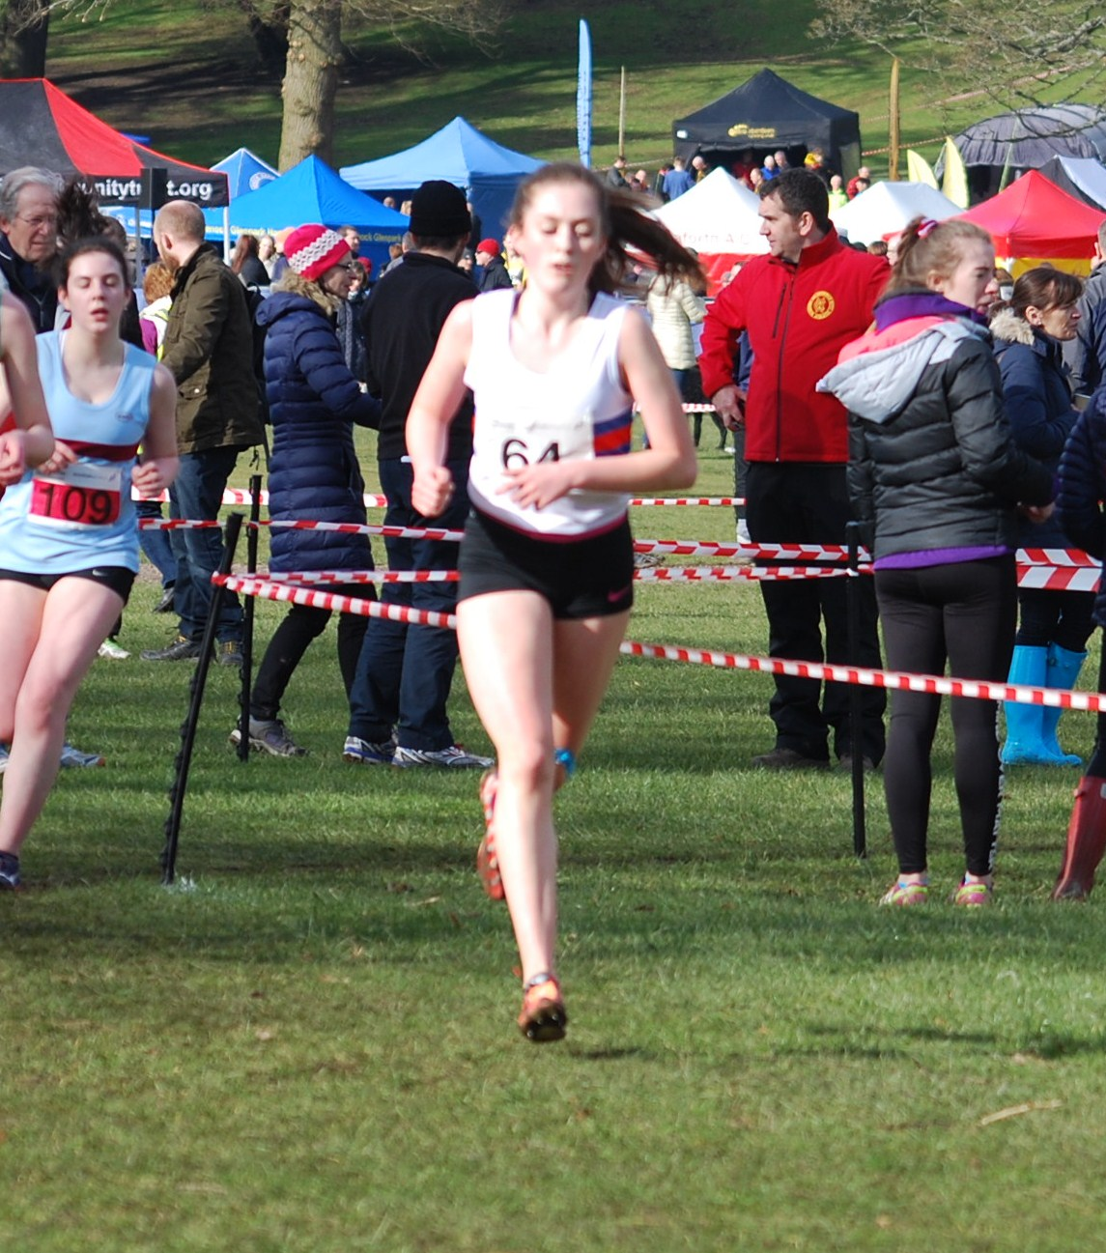

Lauren Dickson heading to the finish and a silver medal! Lauren Wilkie heads out on to the course for the medium lap.

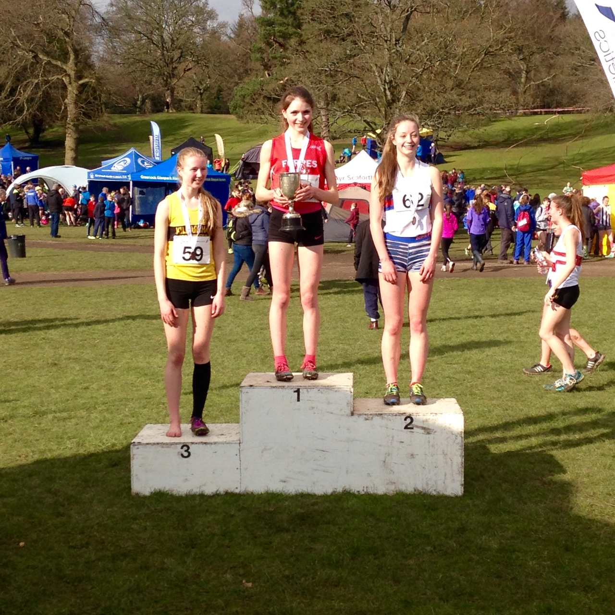

Lauren Dickson receives her silver medal!

The under 20 women ran in the same race as the under 17 women. We only had one under 20 runner, Niamh Shaw who had a strong run to finish 21st out of the 49 finishers.

The under 17 men were running two medium laps and Lasswade had three runners, Matthew Smith, Jamie Darling and Thomas Snodgrass. Matthew had a disappointing race starting off way to conservatively and finishing 51st. Jamie Darling was next home finishing in 80th place. Thomas does not appear to have finished as his name is not in the results.

The day literally flies by with all of these races being run back to back. There were now only a couple of races left. In the women’s race we only had one athlete running, Debbie Urquhart who had a good run to finish in 155th place out of the 264 finishers.

The final event of the day was the senior men with by far the biggest field of the day with 631 finishers. There were seven Lasswade athletes running and they were as follows, Martin Gore the only under 40 running had a good run finishing in 63rd, next home was Ben Mitchell 270th (22nd M45) followed by Andrew McGlone in 311th (26th M45) then Scott Dickson came home in 426th (74th M40), Peter Ness was our next finisher in 445th (56th M45), David Scott was 494th (83rd M40) and Stephen Brown completed the team in 522nd (76th M45).

A great day of cross country we just need more complete teams for next year!

David Scott and Stephen Brown in the men’s race.



